PRACTICAL NO:1
Fundamental of R
Aim: To study the fundamentals of R programming and perform bacis operations using Variables, Arithmetic Operations, Numerical Functions, Descriptive Functions, and different data structures such as Vectors , Lists, Matrices,Arrays,and Data Frames.
Code:
#Arithmetic Operations
> a<-15
> b<-10
> cat("Addition=",a+b,"\n")
Addition= 25
> cat("Subtraction=",a-b,"\n")
Subtraction= 5
> cat("Multiolication=",a*b,"\n")
Multiolication= 150
> cat("Division=",a/b,"\n")
Division= 1.5

#Built-in Functions
> num<-c(12,18,20,25,30)
> cat("Sum=",sum(num),"\n")
Sum= 105
> cat("Mean=",mean(num),"\n")
Mean= 21
> cat("Maximum=",max(num),"\n")
Maximum= 30
> cat("Minimum=",min(num),"\n")
Minimum= 12
> cat("Variance=",var(num),"\n")
Variance= 47
> cat("Standard deviation=",sd(num),"\n")
Standard deviation= 6.855655

#Vector
> marks<-c(70,75,80,85,90)
> print(marks)
[1] 70 75 80 85 90

#Matrix
> mat<-matrix(c(1,2,3,4,5,6),nrow=2,byrow=TRUE)
> print(mat)
[,1] [,2] [,3]
[1,] 1 2 3
[2,] 4 5 6

#Array
> arr<-array(1:12,dim=c(2,2,3))
> print(arr)
, , 1
[,1] [,2]
[1,] 1 3
[2,] 2 4
, , 2
[,1] [,2]
[1,] 5 7
[2,] 6 8

, , 3
[,1] [,2]
[1,] 9 11
[2,] 10 12

#List
> student<-list(Name="Payal",Age=20,Percentage=82.5)
> print(student)
$Name
[1] "Payal"

$Age
[1] 20

$Percentage
[1] 82.5

#Data Frame
> stud<-data.frame(RollNo=c(1,2,3),Name=c("Veena","Sojal","Priyanka"),Marks=c(85,90,88))
> print(stud)
RollNo Name Marks
1 1 Veena 85
2 2 Sojal 90
3 3 Priyanka 88

#Summary
> summary(stud)
RollNo Name Marks
Min. :1.0 Length:3 Min. :85.00
1st Qu.:1.5 Class :character 1st Qu.:86.50
Median :2.0 Mode :character Median :88.00
Mean :2.0 Mean :87.67
3rd Qu.:2.5 3rd Qu.:89.00
Max. :3.0 Max. :90.00

#Structure
> str(stud)
'data.frame': 3 obs. of 3 variables:
$ RollNo: num 1 2 3
$ Name : chr "Veena" "Sojal" "Priyanka"
$ Marks : num 85 90 88

#Class
> class(stud)
[1] "data.frame"

PRACTICAL NO.2
Graphs using R
Aim: To study create different type of graphs using R for visual representation and analysis of data.
Code:
# Line Graph
> x<-c(1,2,3,4,5)
> y<-c(10,20,15,25,30)
> > plot(x,y,type="l",col="Blue",lwd=2,main="Line Graph",xlab="X",ylab="Y")

Output:
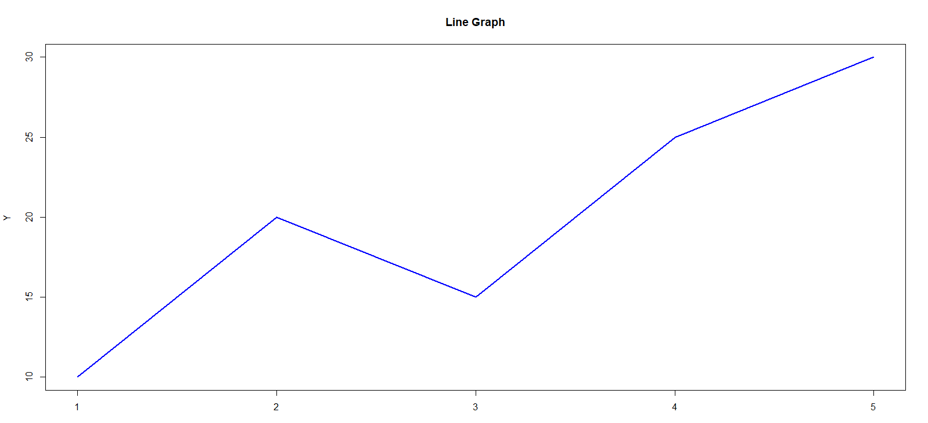

# scatterplot
Code:
> plot(x,y,pch=19,col="Red",main="Scatterplot")
Output:
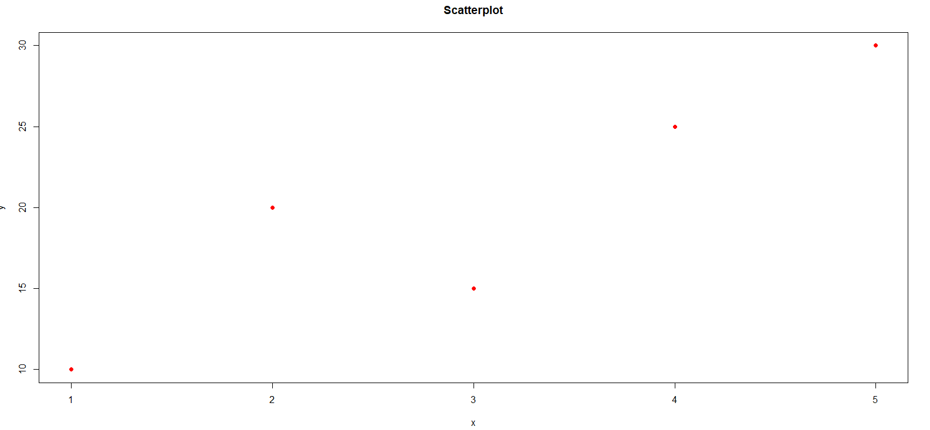
# Boxplot
Code:
> marks<-c(65,70,75,80,85,90)
> boxplot(marks,main="Box plot",col="Light green")
Output:
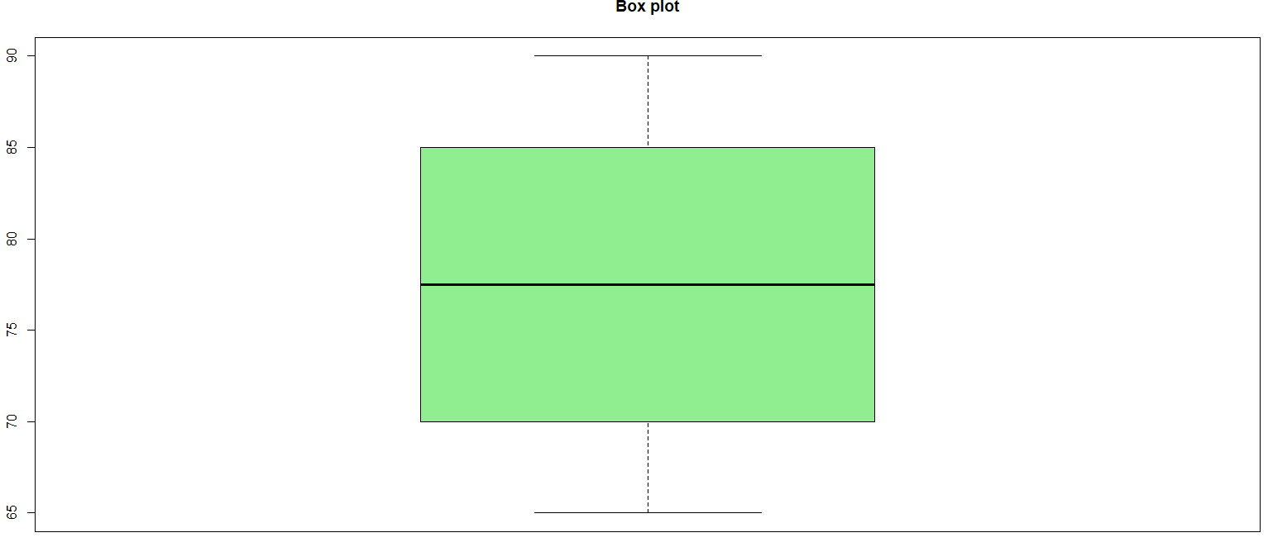

PRACTICAL NO.3
Digram Using R
Aim: To study and create different types of diagrams using R for the graphical representation and interpretation of data.
Code:
#Bar Digram
> sales<-c(20,30,25,35)
> barplot(sales,names.arg=c("Jan","Feb","Mar","Arp"),
+ col="skyblue",
+ main="Sales")

Output:
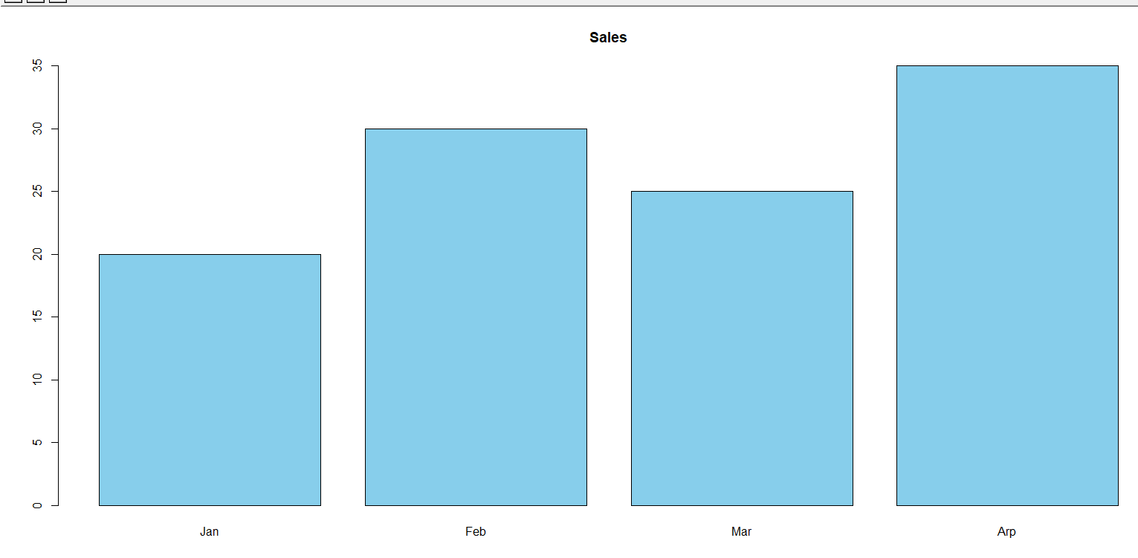

#Pie Digram
Code:
> expense<-c(40,25,20,15)
> pie(expense,labels=c("Food","Travel","Rent","Other"),
+ main="Expense")
Output:

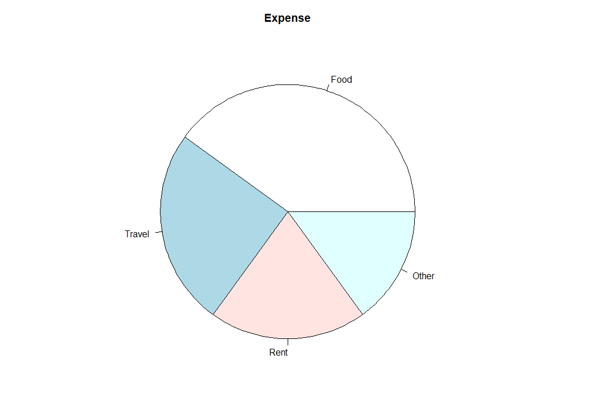

#Histogram
Code:
> marks<-c(50,55,60,65,70,75,80,85,90)
> hist(marks,
+ col="yellow",
+ main="Histogram",
+ xlab="Marks")
Output:

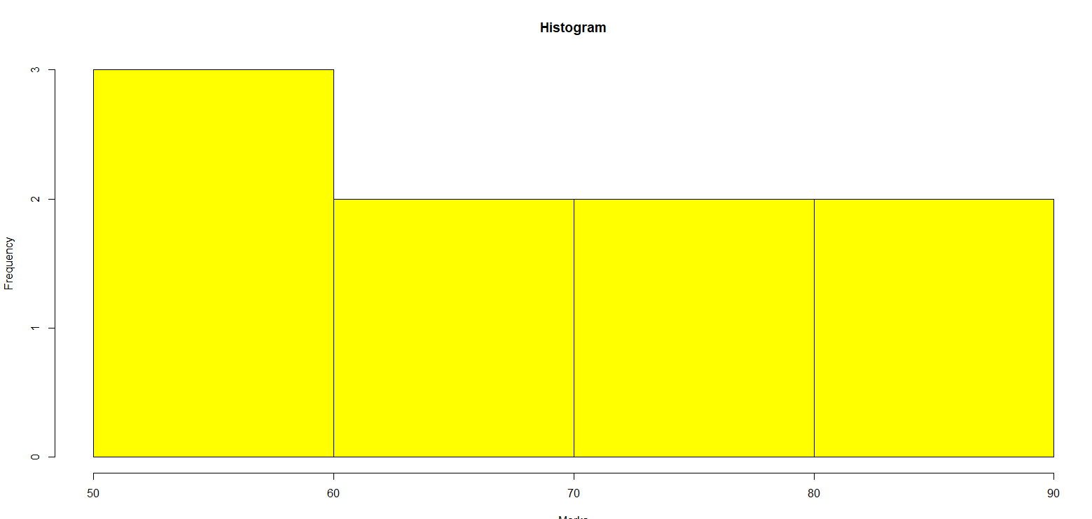

PRACTICAL NO:04
Simple Linear Regression Using R
Aim: To fit a Simple Linear Regression model using R and analyze the relationship between an independent variable and a dependent variable using correlation, regression coefficients, R², Adjusted R², t-test, F-test, confidence interval, prediction, and residual analysis.
Code:
> Hours <- c(2,3,4,5,6,7,8,9,10,11)
> Marks<- c(45,50,55,60,65,68,72,78,82,88)
> data<- data.frame(Hours, Marks)
> print(data)
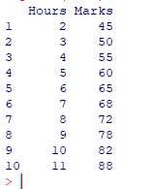
> correlation <- cor(Hours,Marks)
> cat("correlation=", correlation,"\n")
correlation= 0.99868
> model<-lm(Marks ~ Hours, data = data)
> print(model)
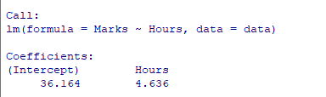

> summary(model)
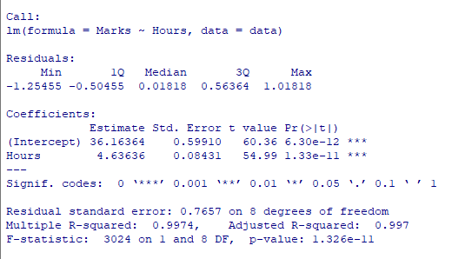> confint(model)
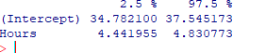
> fitted_values<-fitted(model)
> residual_values<-residuals(model)
> cat("fitted values:\n")
fitted values:
> print(fitted_values)
> cat("residual:\n")
residual:
> print(residual_values)
> plot(Hours, Marks)
> plot(Hours, Marks, main="Simple linear regression", xlab="Hours studied", ylab="Marks obtain",pch=19)
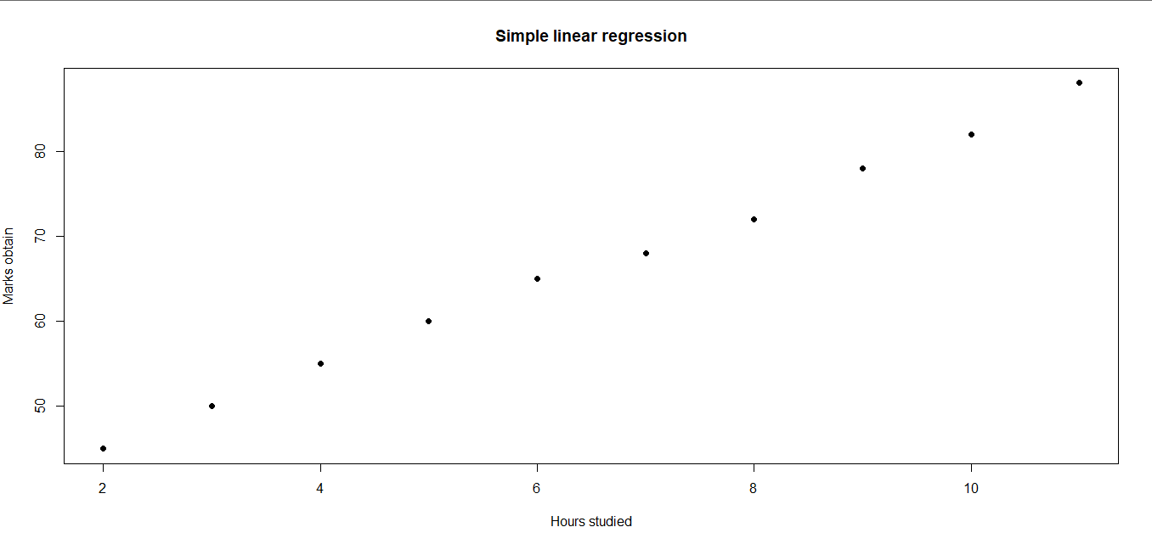
> abline(model, lwd=2)
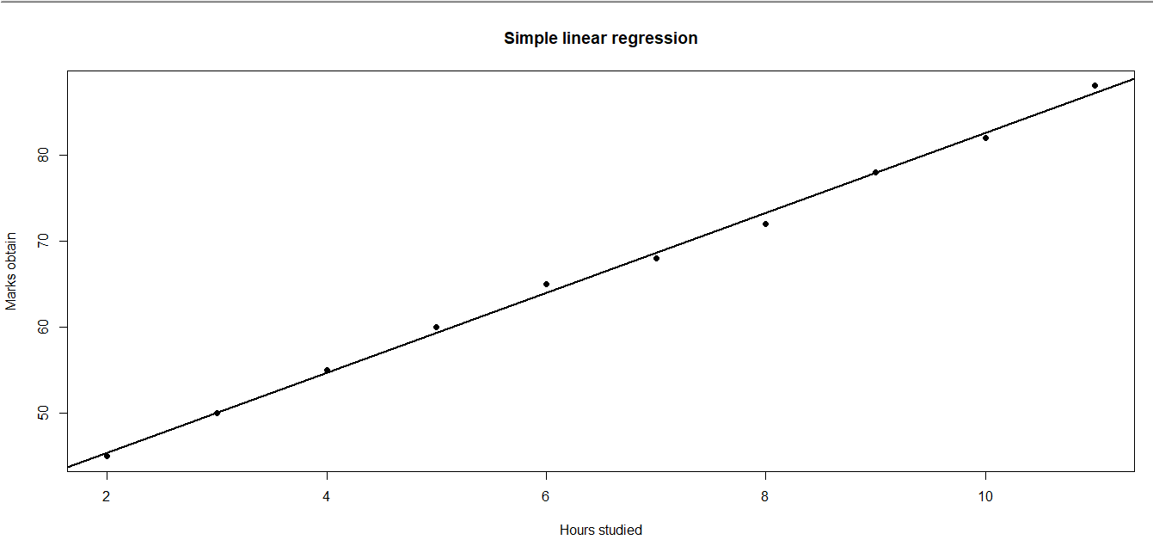
> new_data<-data.frame(Hours=12)
> prediction<-predict(model, newdata=new_data, )
> prediction<-predict(model, newdata=new_data,interval="confidence" )
> cat("Predicted marks for 12 Hours:\n")
Predicted marks for 12 Hours:
> print(prediction)
fit lwr upr
1 91.8 90.59372 93.00628
> par(mfrow= c(2,2))
> plot(model)
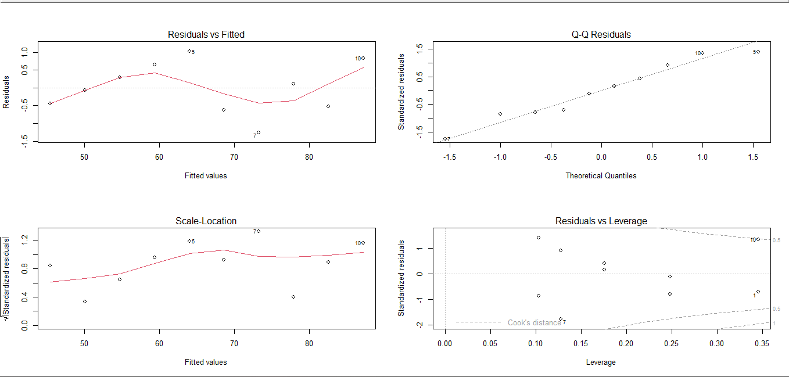
> par(mfrow= c(1,1))
> plot(model)
Waiting to confirm page change...
Waiting to confirm page change...
Waiting to confirm page change...
Waiting to confirm page change...

PRACTICAL NO.5
Weighted Least Square Using R
Aim: To fit a Weighted Least Squares (WLS) regression model using R and study the effect of weights on regression analysis.
Code:
> x <- c(1, 2, 3, 4, 5)
> y <- c(1.2, 2.1, 2.9, 4.2, 5.0)
> w <- c(1, 2, 3, 4, 5)
> data <- data.frame(x, y, w)
> print(data)
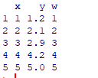
> model <- lm(y ~ x, data = data, weights = w)
> summary(model)
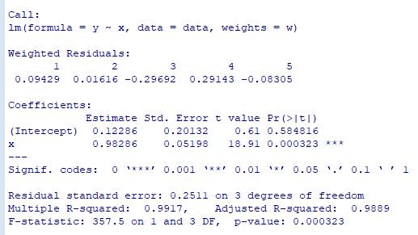
> anova(model)
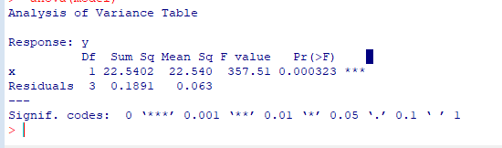
> confint(model)
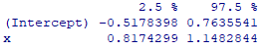
> fitted_values <- fitted(model)
> print(fitted_values)
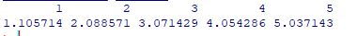
> residual_values <- residuals(model)
> print(residual_values)
> print(coef(model))
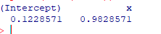
> cat("Regression Equation: ")
> cat("Regression Equation: ")

> plot(x, y,
+ pch = 19,
+ main = "Weighted Least Squares Regression",
+ xlab = "Independent Variable (X)",
+ ylab = "Dependent Variable (Y)")
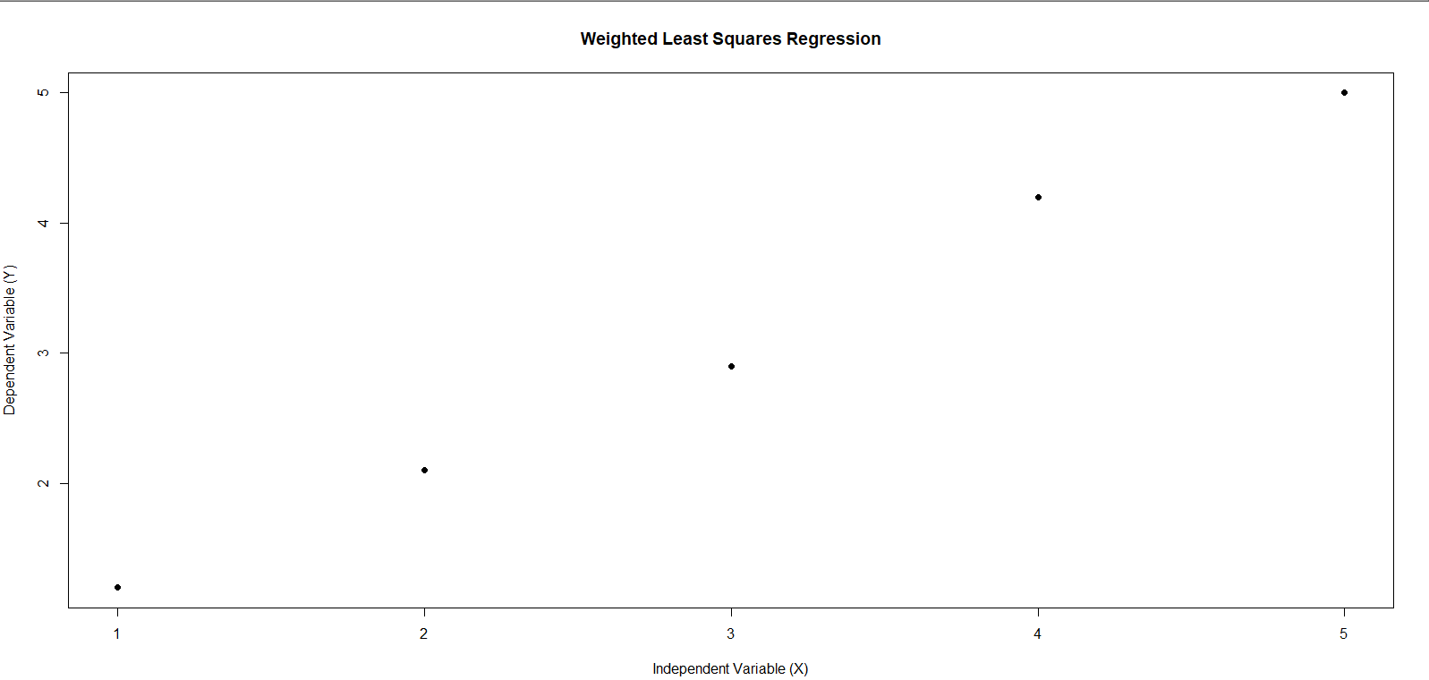
> abline(model, lwd = 2)
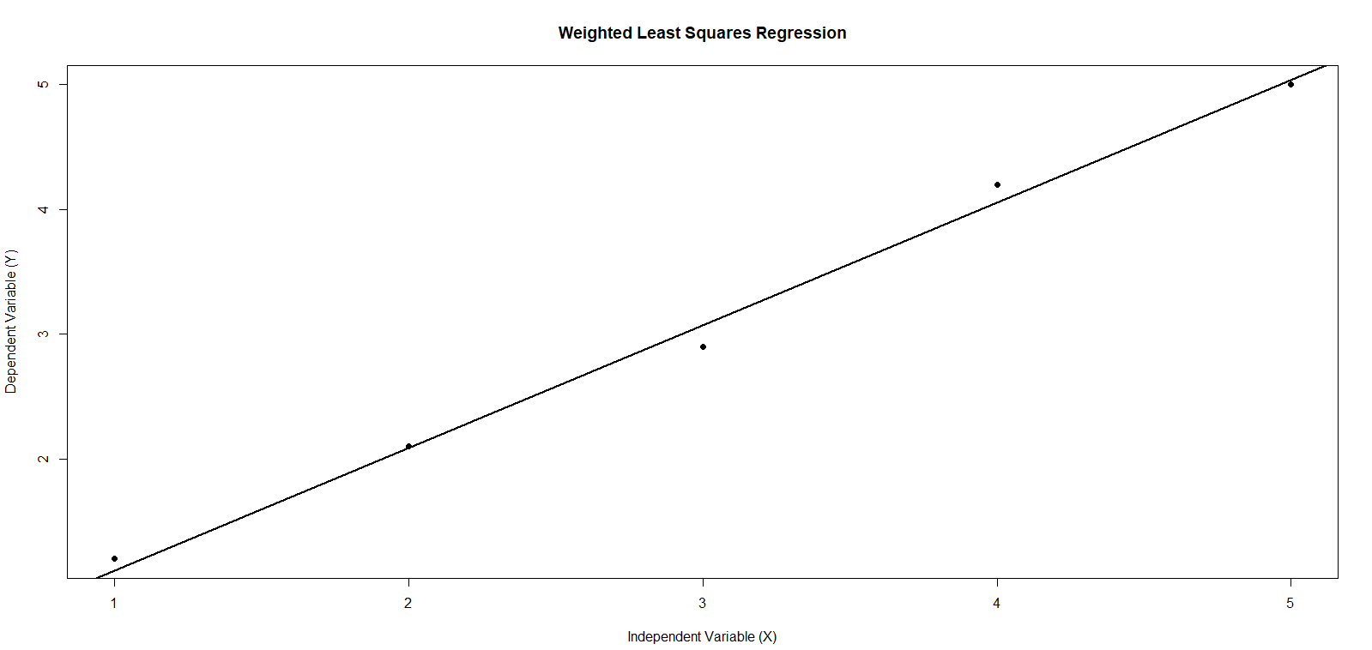

PRACTICAL NO:6
Multiple Linear Regression and Ridge Regression
Aim: To perform Multiple Linear Regression and using R and study the significance of regression coefficients.
Code:
# Display Dataset
> data(mtcars)
> head(mtcars)
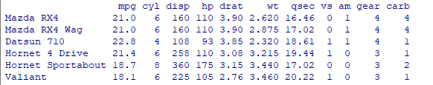
#Multiple linear Regrassion
> model<-lm(mpg~wt+hp+disp,data=mtcars)
#Display Model
> summary(model)
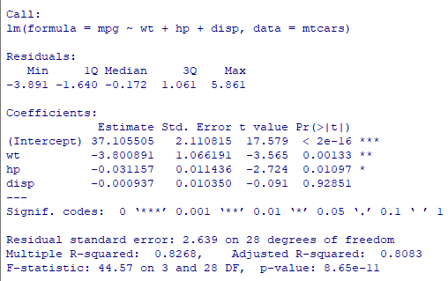

#ANOVA
> anova(model)
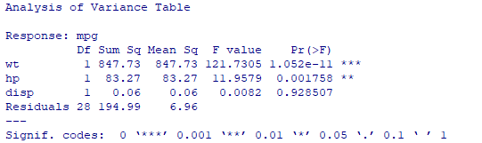
# Confidence Intervals
> confint(model)
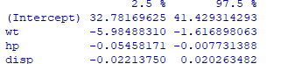
#Predicted Vslues
> predicted<-predict(model)
> print(predicted)
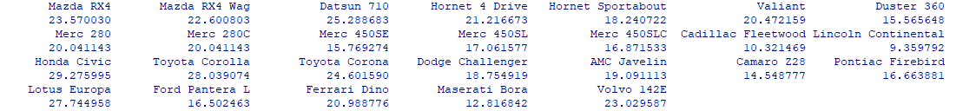

#Residuals
> residuals<-residuals(model)
> print(residuals)
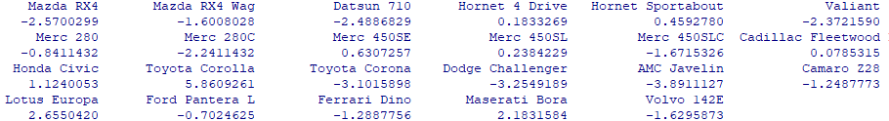

#Multiple Lenear Regression plot
> plot(mtcars$mpg,predicted,main="Actual vs Predicted MPG",xlab="Actual MPG",ylab="Predicted MPG",pch=19)
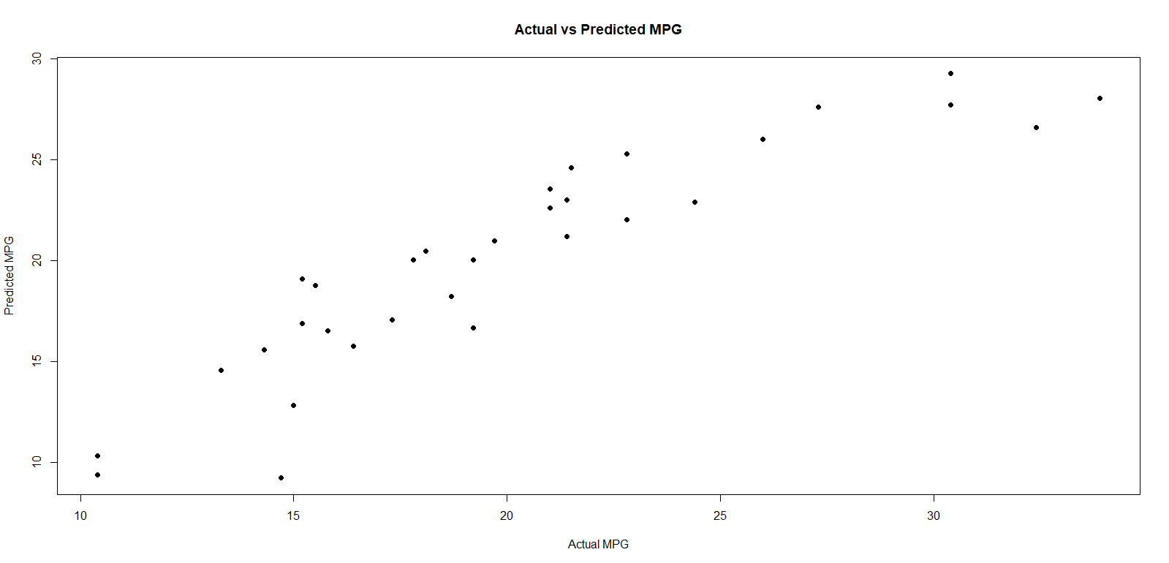
> abline(0,1)

#Ridge Regression
#Install package only once if required
#install.packages(“glmnet”)

> library(glmnet)
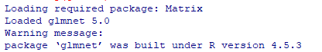

#Independent Variavles
> x<-model.matrix(mpg~wt+hp+disp,data=mtcars)[,-1]
#Dependent Variable
> y<-mtcars$mpg
#Ridge Regression Model
> ridge_model<-glmnet(x,y,alpha=0)
> print(ridge_model)
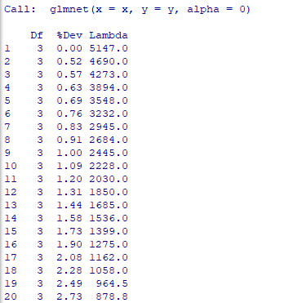

> coef(ridge_model)

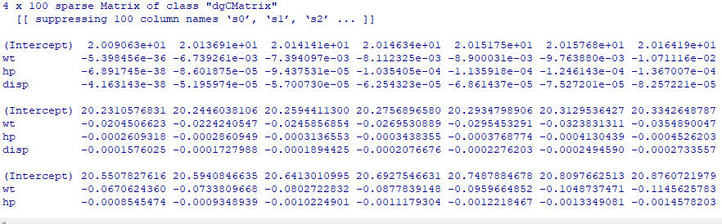

> plot(ridge_model,xvar="lambda",label=TRUE,main="Ridge Regression")

